**Ideation Phase**

**Empathize & Discover**

|  |  |
| --- | --- |
| Date | 31 January 2025 |
| Team ID | **LTVIP2025TMID45799** |
| Project Name | TrafficTelligence: Advanced Traffic Volume Estimation with Machine Learning |
| Maximum Marks | 4 Marks |

**Empathy Map Canvas:**

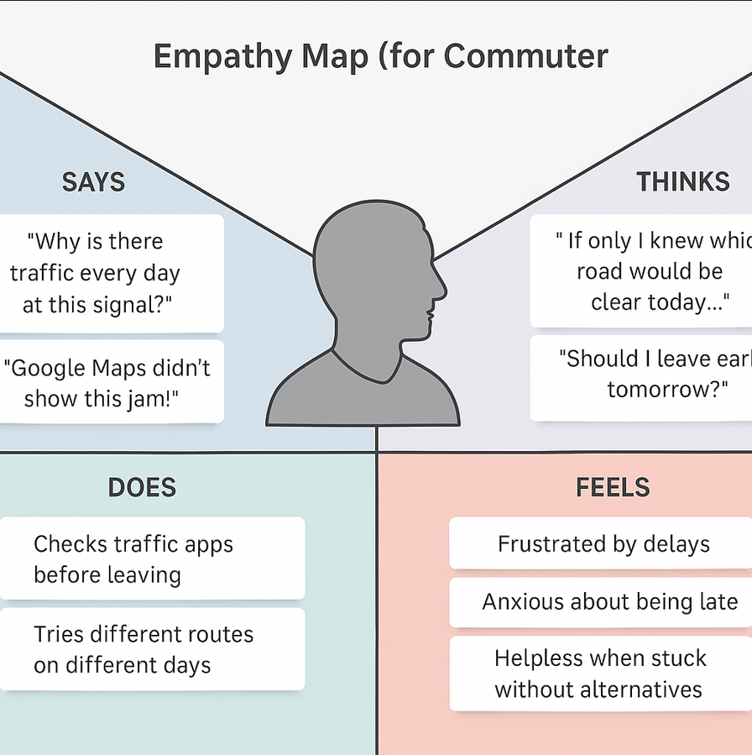**Example:**

Reference: <https://www.mural.co/templates/empathy-map-canvas>

**Domain:** TrafficTelligence – Smart Traffic Estimation System  
**Persona:** A daily urban commuter  
**Problem:** Wants to reach office on time but gets delayed due to unpredictable traffic  
**Empathy Map Use:** Understand commuter frustrations, behaviors, and needs during daily travel

**Traffic Intelligence Application**  
A working professional commutes daily through heavy traffic zones. Despite using navigation apps, unexpected jams and inaccurate predictions cause frequent delays. An empathy map helps uncover what they say, think, do, and feel to better design solutions using predictive AI traffic models.